#include <iostream>
#include <vector>
#include <queue>
using namespace std;

// DFS Function
void DFS(int vertex, vector<vector<int>>& graph, vector<bool>& visited) {
visited[vertex] = true;
cout << vertex << " ";

for (int neighbour : graph[vertex]) {
if (!visited[neighbour]) {
DFS(neighbour, graph, visited);
} } }

// BFS Function
void BFS(int start, vector<vector<int>>& graph, int V) {
vector<bool> visited(V, false);
queue<int> q;
q.push(start);
visited[start] = true;

while (!q.empty()) {
int vertex = q.front();
q.pop();

cout << vertex << " ";

for (int neighbour : graph[vertex]) {
if (!visited[neighbour]) {
visited[neighbour] = true;
q.push(neighbour);
}
}
}
}
// Main Function
int main() {
int V = 4; // Number of vertices
vector<vector<int>> graph(V);
// Undirected graph edges
graph[0].push_back(1);
graph[1].push_back(0);

graph[0].push_back(2);
graph[2].push_back(0);

graph[1].push_back(3);
graph[3].push_back(1);

graph[2].push_back(3);
graph[3].push_back(2);
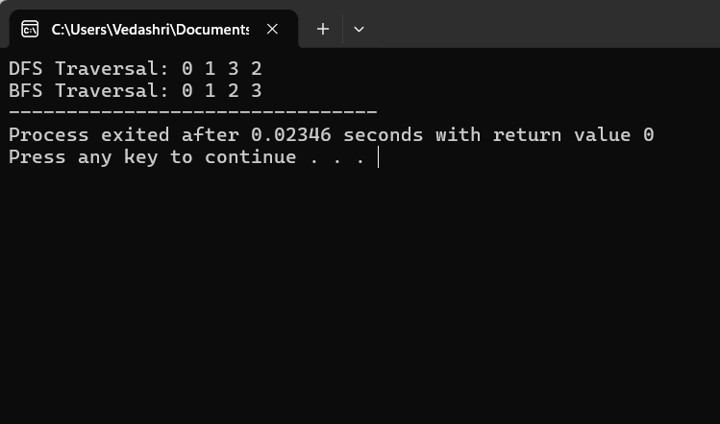
vector<bool> visited(V, false);

cout << "DFS Traversal: ";
DFS(0, graph, visited);

cout << "\nBFS Traversal: ";
BFS(0, graph, V);

return 0;
}

